**DBMS Assignment – 2**

* *Shoppie - A desktop Shopping Application*

Name : J.Siddharth

Roll no : 1602-19-737-172

Section : IT-C

**NORMALIZATION:**

Normalization is the process of minimizing redundancy from a relation or set of relations. Redundancy in relation may cause insertion, deletion and updation anomalies. So, it helps to minimize the redundancy in relations. Normal forms are used to eliminate or reduce redundancy in database tables.

There are different types of normal forms:

**a.** 1 st Normal Form

**b.** 2 nd Normal Form

**c.** 3 rd Normal Form

**d.** BCNF Normal From

**e.** 4 th Normal Form

**f.** 5 th Normal Form

The above tables are created to avoid repetition of values in the main table and manage mainly many – to – many relationships. All the above tables are in 3 rd Normal Form and are free from Insertion, Deletion and Updating Anomalies.

**List of Tables :**

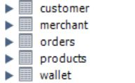

**Tables in 3rd Normal Form**

**Products Table**

**Attributes :**

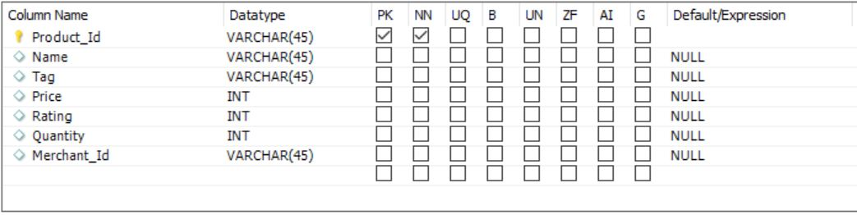

**Primary key** : Product_Id **Foreign Key** : Merchant_Id

**Table :**

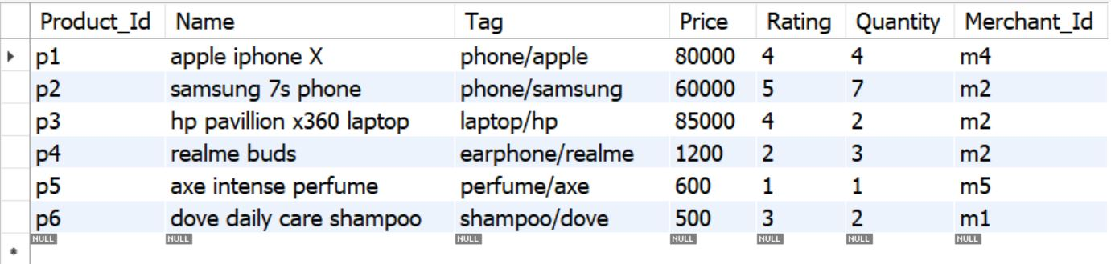

**Orders Table**

**Attributes :**

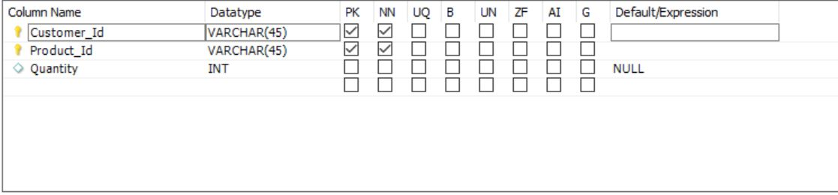

**Primary key** : Customer_Id, Product_Id **Foreign Key** : Customer_Id, Product_Id

**Table :**

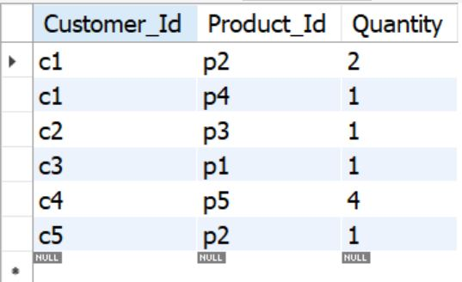

**Wallet Table**

**Attributes :**

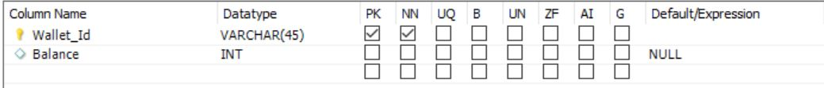

**Primary key** : Wallet_Id

**Table :**

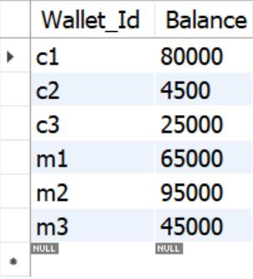

**Customer Table**

**Attributes :**

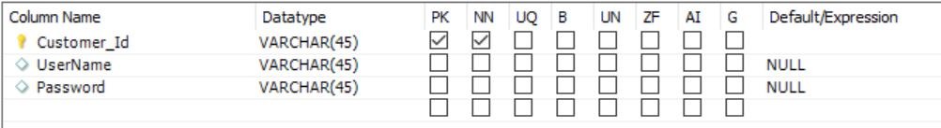

**Primary key** : Customer_Id

**Table :**

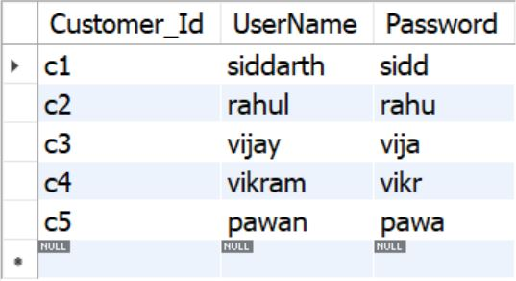

**Merchant Table**

**Attributes :**

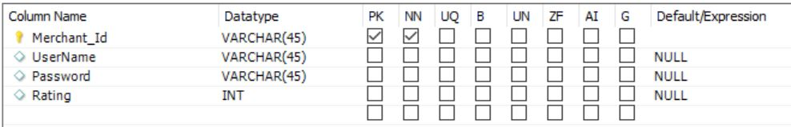

**Primary key** : Merchant_Id

**Table :**

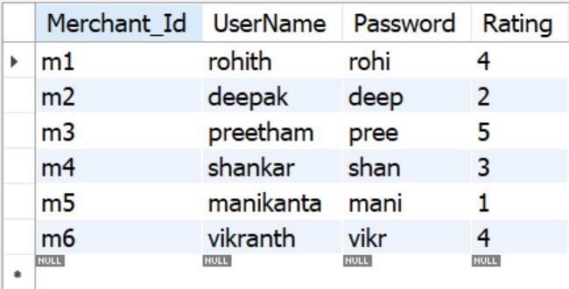

**ER Diagram**

